

**IT7x22 - Assignment One**

**Research Report**

**Semester 2, 2018**

**Mobile Apps - Web vs. Native vs. Hybrid?**

**Cross-platform Development?**

**Xamarin?**

**School of Information Technology**

# Abstract:

A summary of your research project: Describes the content and scope of the project and identifies the project’s objective, its methodology and its findings and conclusions.

Take a look at the different types of mobile applications that exist and do a little bit of comparison from the standpoint of a company looking to build or hire someone to build a mobile application and this is a huge choice it could make or break a company's success in the mobile app world so we're going to compare web apps native and hybrid apps and we'll talk about the differences we'll also look at the advantages and disadvantages of each

There's basically three main types of mobile apps there is a grey area which I'll get into later but for the most part we have web apps native apps and hybrid apps

# Introduction

Introduction of your report

Background information

Clarification of the purpose of study

Research question or general hypotheses to be tested

# Methodology

Methodologies you use to underpin your work and methods you use in order to collect data for this study.

**Mixed method** research involves collecting and analyzing both quantitative and qualitative data. The quantitative data includes closed-end information that undergoes statistical analysis and results in a numerical representation. Qualitative data, on the other hand, is more subjective and open-ended. It allows for the “voice” of the participants to be heard and interpretation of observations.

Collect data using a quantitative data instrument. The researcher may then follow up by interviewing a subset of the participants to learn more detailed information about some of the survey responses, providing a more thorough understanding of the results.

# Brief Explanations

## Web Apps / Mobile Websites

* Built using HTML/CSS/JavaScript
* Runs inside a browser (Internet Explorer, Chrome, Safari, etc)
* Built like a regular website or web app
* Designed to look good on mobile devices

Advantages

* Easy to build (HTML/CSS/JS)
* Easy to maintain
* Use any technology/language
* Cheaper than native and hybrid apps
* Single app for all platforms

Cons

## Native Mobile Apps

* Most common type of mobile app
* Built for specific platforms
* Build using native programming languages

Advantages

Cons

## Hybrid Apps

* Combination of native & web apps
* Uses HTML/CSS/JavaScript
* Ran inside of a container / webview

Advantages

Cons

# Literature review

A review of the past and present literature in relation to your research purpose relevant literature specific to the study

# A Comparative Analysis of Cross-platform Development Approaches for Mobile Applications

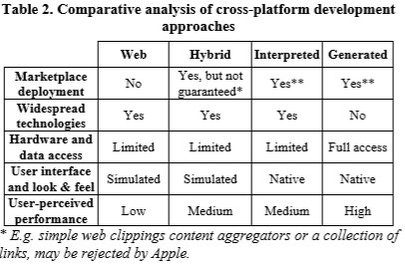

# Native Apps vs. Mobile Web Apps

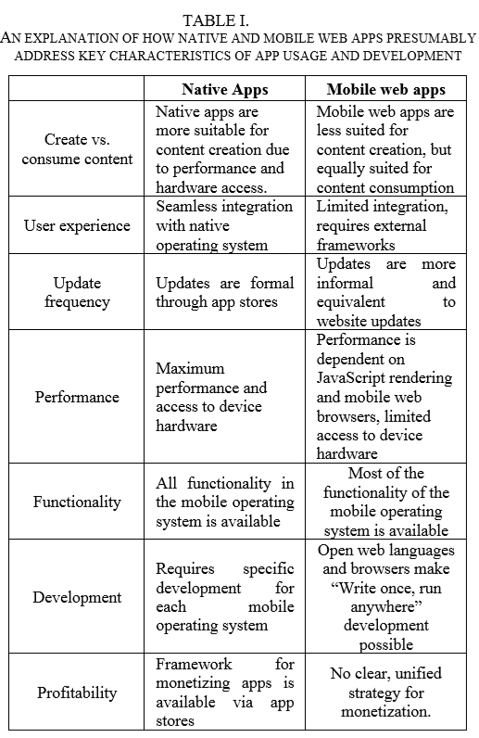

# Mobile Application Development: Web vs. Native

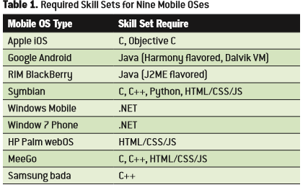

# Summary /conclusion

relevant to the content

Summary of what has been written about in the literature review.

It should not be a repetition of the entire contents of the literature review, but rather an account of current state of knowledge on your topic in the study.s

In addition, there should be a sense that you have explained the background to your study that endorses the decision you have made to study your topic

# References

materials from other sources are clearly referenced

*S xanthopoulos, S.X & S xinogalos, S.X. (2014). A Comparative Analysis of Cross-platform Development Approaches for Mobile Applications. A Comparative Analysis of Cross-platform Development Approaches for Mobile Applications, 1(1), 213-220.*

*A charland, A.C & B leroux, B.L. (2011). Mobile Application Development: Web vs Native. Web apps are cheaper to develop and deploy than native apps, but can they match the native user experience?, 1(1), 1-9.*

*W jobe , W.J. (2013). PAPER NATIVE APPS VS MOBILE WEB APPS . Native Apps vs Mobile Web Apps , 7(4), 27-32.*